**KUSUM KUMARI**



**PERSONAL DETAILS:**

* Class: II
* Gender: Female
* School: Gayatri Shiksha Niketan,

Adityapur

* Board of School: CBSE
* Medium of instruction: English

**DETAILS ABOUT FAMILY:**

* Father’s name: Bhakta Bahadur
* Mother’s name: Krishna Maya
* No of members in family: Four, one baby brother, mother and father
* Profession of father: Machine operator in a local company in Adityapur Industrial Area
* Profession of mother: Housewife

**FINANCIAL OVERVIEW:**

Monthly net income of household: Rs. 2900/-

**Total annual expenditure on education: Rs. 14,700/-**

Breakup of expenses

Tuition fees: Rs 500/- (per month) = Rs. 6000/- (per year)

Admission fees: Rs. 1800/- (per year)

Stationery: Rs. 3300/- (per year)

Auto fare: Rs. 300/-(per month) = Rs. 3600/-(per year)

**Average monthly expenditure on education: Rs. 1225/-**

**ENCLOSURES:**

1) Report card for the final exam of class I (previous class attended).

Report card – Page 1

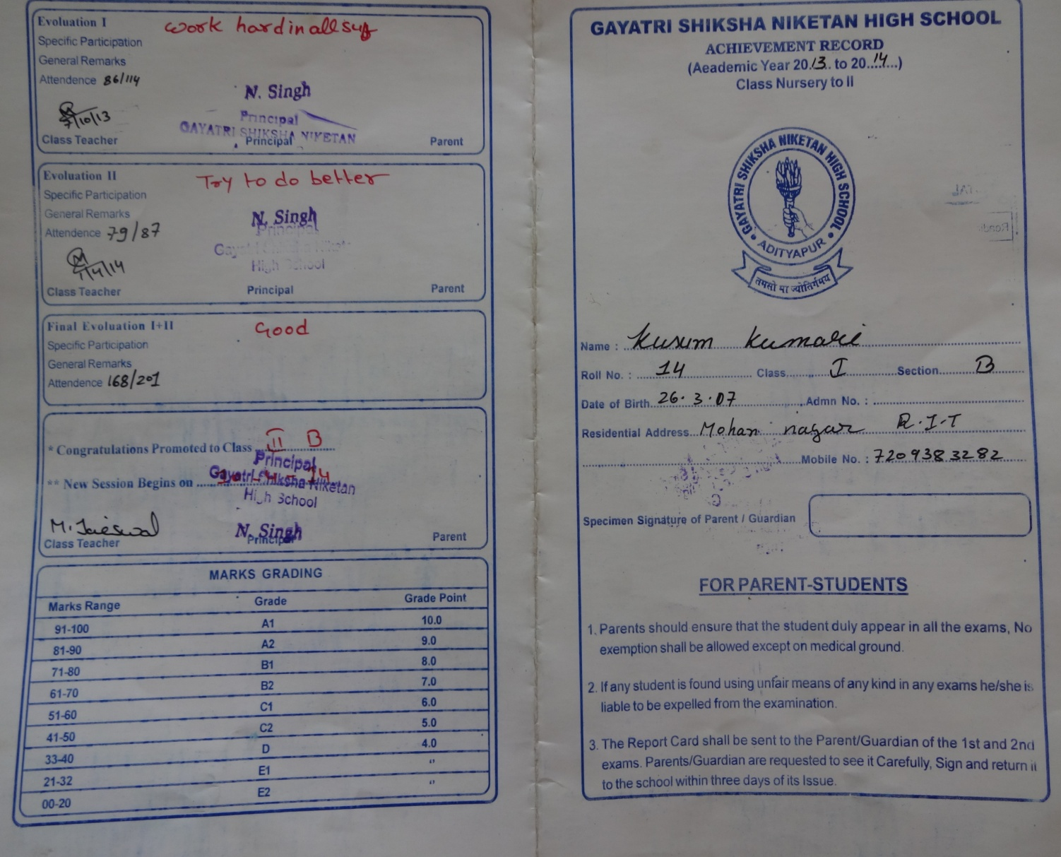

Report card – Page 2

